Paupong; a new gold-silver-copper field in the SE Lachlan
Russell Fountain

Abstract

Introduction
The Paupong Project, located in the south eastern Lachlan Orogen 20km south-east of Jindabyne in southern NSW, is an exciting greenfields discovery of Au, Ag and Cu mineralisation in an area of negligible previous mining activity. Significantly gold-mineralised quartz veins with spot grades up to 14 g/t Au and 125g/t Ag have so far been located by surface prospecting over an area of at least 8 km north‐south and 4 km east-west.
Initial drilling in the Tom’s and Telford’s prospects, partly funded by a NSW Government “New Frontiers Drilling Initiative” $200,000.00 drilling grant, has confirmed the existence of a major Au, Ag and Cu mineralised hydrothermal quartz sulphide vein system, with Tom’s Vein shown to extend over 1.5 km in strike length, with estimated true thickness up to 20m.
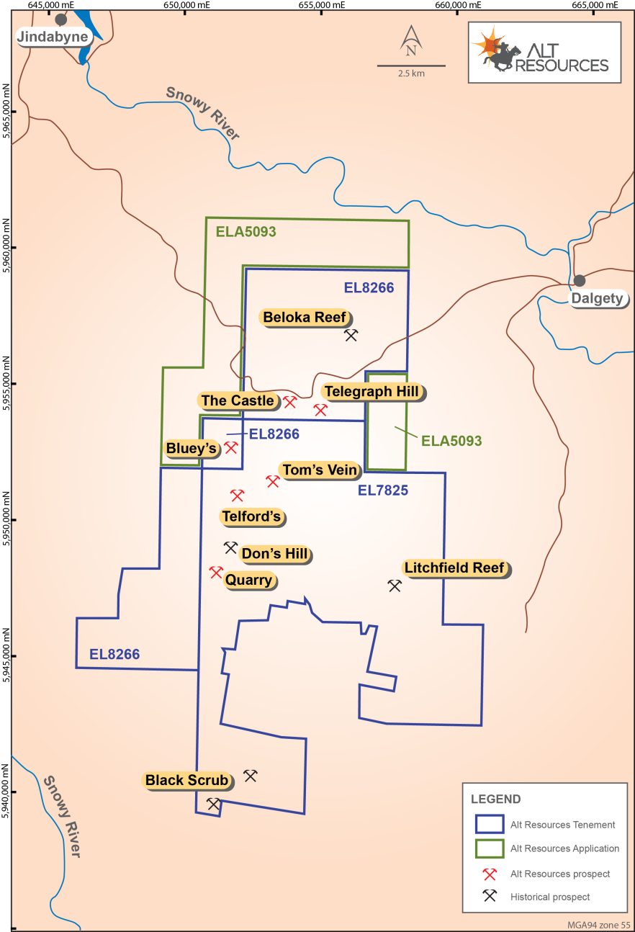
Figure 1 Project Location Map
The outcropping vein and stockwork hosted gold-silver mineralisation, which is the focus of current exploration at Paupong, was discovered in mid 2013 after an initial drilling program by GFM Exploration Pty Ltd (GFM), and is being explored as a joint venture (The JV) with Alt Resources Ltd, which is currently seeking listing on the ASX through an initial public offering. The Alt prospectus and Supplementary prospectus are available on the company’s website at www.altresources.com
The prospect area comprises dominantly cleared grazing land with low relief and a very mature weathering profile, evidenced by significant remnants of cap-rock relating to a pre-Tertiary weathering surface, extensive soil development and limited outcrops.
Two factors are significant in the failure of previous explorers to discover the outcropping gold mineralisation;
The very fine grain-size of (mainly supergene) gold in the weathered, outcropping mineralisation making it undetectable by traditional panning techniques; and, minimal and cursory modern geochemical exploration in the area during the 1970’s which was never followed up by the previous explorers.
The project is in a very early stage of exploration. To date, only 20% of the 183 km² of the tenement has been prospected by The JV, and the limits of the gold bearing system have not yet been defined. Work by the JV has comprised surface prospecting, geological mapping and selective rock chip sampling of veins, reprocessing and interpretation of aeromagnetic data from the SE Lachlan aeromagnetic survey, plus ground resistivity and gradient array and dipole-dipole IP surveys. Assisted by a $200,000 grant from the NSWDTIR, The JV has recently completed 21 shallow RC holes across the Tom’s and Telford’s prospects for approximately 2,090m of RC. Four RC holes were extended with diamond tails for a total of 2,700m first pass drilling (including 625m diamond).

Local Geological Setting
In the Paupong prospect area, deep water sediments, comprising impure sandstones, siltstone, black shale and minor chert of the Ordovician Adaminaby Group, are tightly folded about a near north-south axis. The sedimentary package is bounded to the west by the Kosciusko Batholith and the east by the Berridale Batholith and intruded by a swarm of small intrusive stocks. Some are composite fractionated bodies that are of I-type affinity indicating mineralising potential (Chappell et al., 1988).
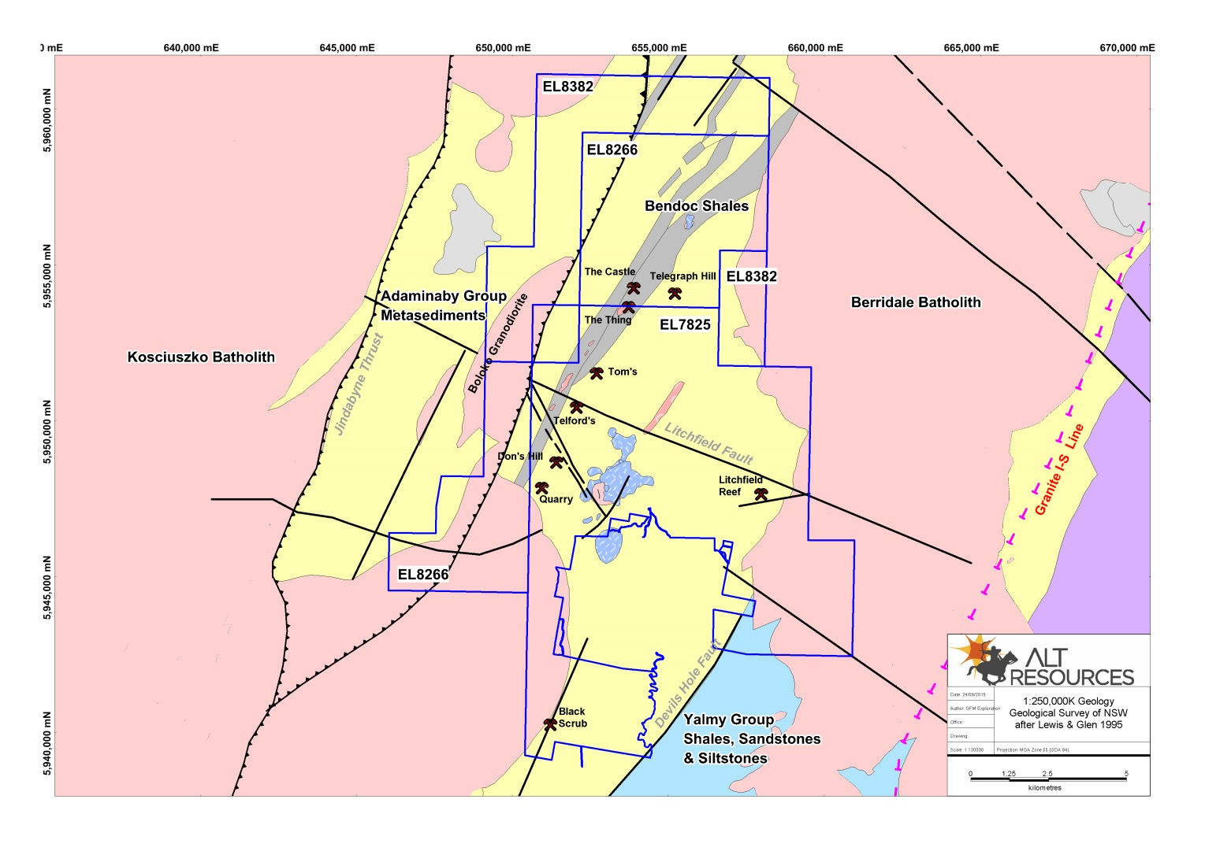
Figure 2 Project geology from Bega-Mallacoota 1:250,000 sheet
Fourteen outcropping intrusions have been identified to date in the Paupong project area. They have variable felsic compositions and four show features suggesting they could be of great interest as mineralising intrusive centres. Additional non-outcropping intrusive bodies are interpreted at depth from aeromagnetic data, but these range from non-magnetic to strongly magnetic suggesting variation in primary igneous composition and/or alteration intensity.
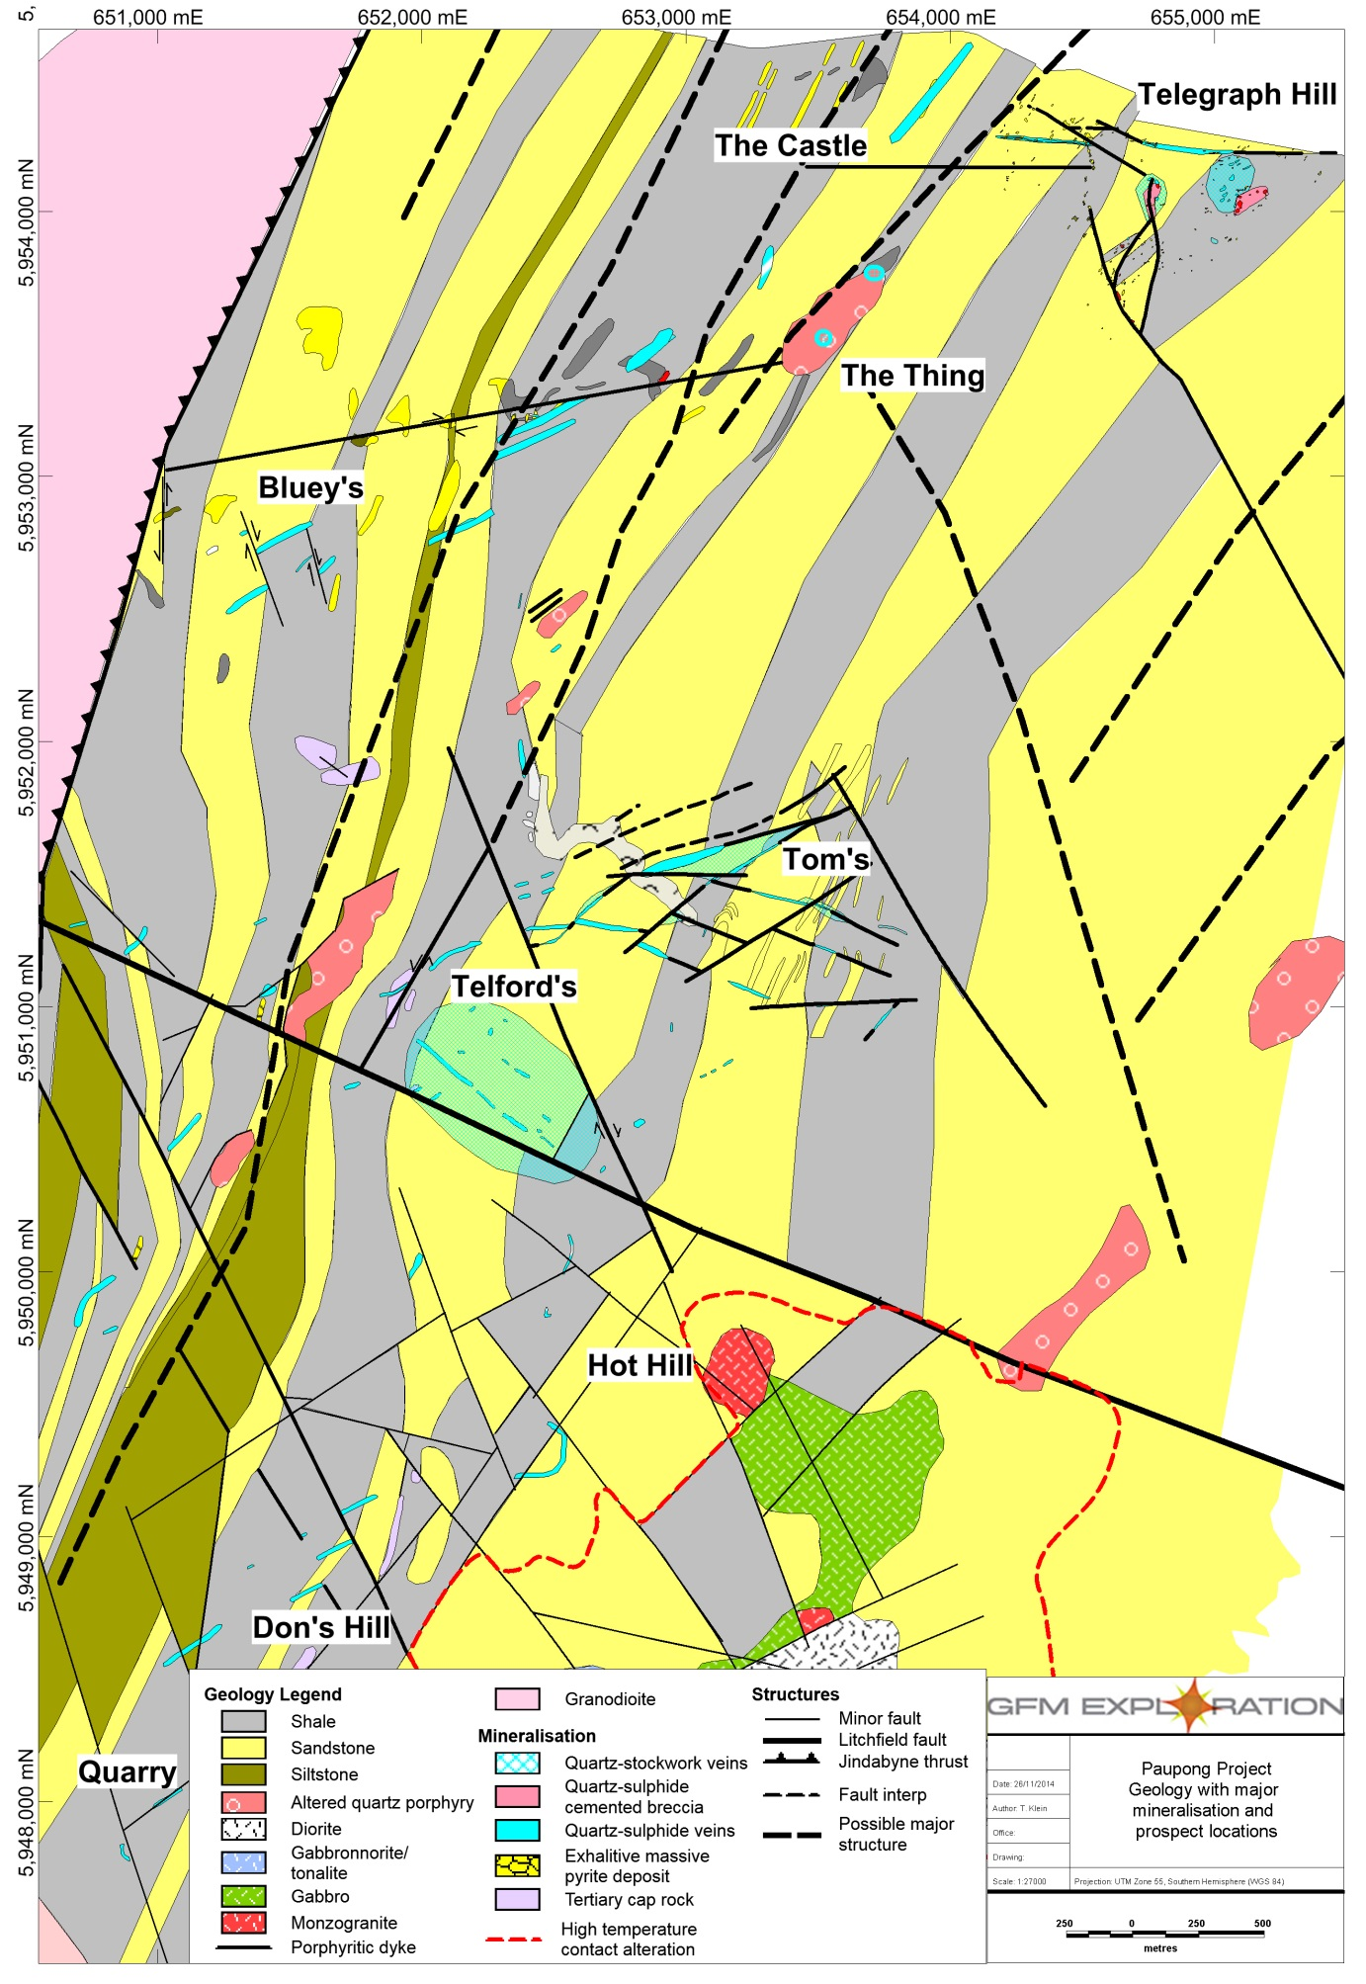
Figure 3 Central prospect area geology
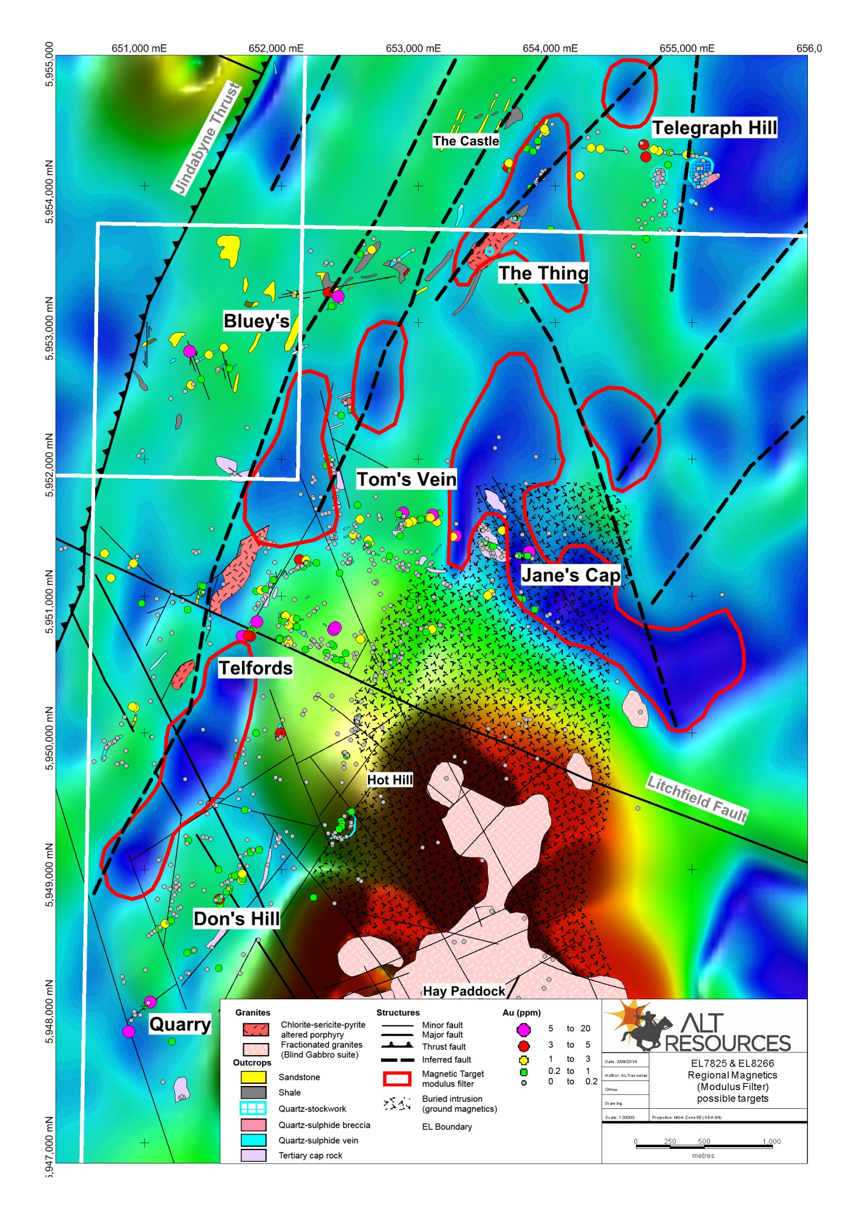
Figure 4 Modular filtered aeromag

Field observations suggest that the intrusive outcrops fall into two distinct classes on the basis of their observed joint patterns and alteration.
Closely jointed (spaced 10cm or less apart) bodies, with well developed, generally sub-planar joints in at least 2 directions (J Type) include the Thing, Middle Creek and Litchfield intrusives as currently mapped. The observed J type outcrops show mineral coatings, either quartz micro veins, veins or chlorite and/or sulphide coatings, on the joint faces. They are granodioritic to monzonitic porphyries, with patchy intense plagioclase alteration to albite and sericite, and chlorite almost completely replacing original biotite and/or hornblende phenocrysts (based on petrology for the Thing and Middle Creek intrusions). They are non-magnetic and show evidence of tectonic deformation, indicating that they are syntectonic in age. At the Thing prospect the J Type porphyry is cut by gossanous stockwork quartz veins with a similar geochemical signature to the widespread gold bearing quartz veins which comprise the Paupong prospect. We interpret the J type bodies as potential source intrusives for porphyry style copper gold mineralisation at Paupong.
More massive, weakly jointed outcrops with generally spheroidal weathering and joint spacing generally >50cm (M type) range from gabbro through granodiorite to micromonzonite, and comprise the Blind Gabbro Complex. They are moderately to strongly magnetic, significantly less altered than the J Type, and most likely post date the main mineralising events at Paupong. A monzogranite member of the Blind Gabbro complex was recently (U-Pb) dated at 387 Ma (upper Middle Devonian).

Initial Drilling Results

Tom’s Prospect
Initial drilling has focused on the coincident surface mapping and IP chargeability in the eastern portion of the 070 trending Tom’s vein structure (Fig 5) The main structure was intersected on all test lines as a broad zone of brecciated and rehealed quartz sulphide veins and stockworks, up to 50m wide down hole (estimated true thickness ~ 20m).
Anomalous intercepts from Tom’s vein are tabulated below. Geochemically, the vein intercepts are unevenly mineralised, with grades Au and Cu grades very roughly corresponding to the total sulphide content, and associated with strongly anomalous As, Bi, Co and lesser Mo.
Hole ID |  | From  (m) | To  (m) | Width  (m) | Au  (g/t) | Ag  (g/t) | Cu  (%) | Zn (%)
PDD001 | incl and | 211  211  214 | 215.6  212  214.9 | 4.6  1.0  0.9 | 0.89  1.30  1.45 | 3.05 | 0.24 | 0.007  0.007  0.001
 |  |  |  |  |  | 4.80 | 0.65
 |  |  |  |  |  | 2.80 | 0.15
PDD002 |  | 56 | 67 | 11.0 | 0.64 | 4.16 | 0.30 | 0.001
 | incl and | 56  57 | 61  59 | 5.0 | 1.26 | 7.42 | 0.50 | 0.002  0.002
 |  |  |  | 2.0 | 2.36 | 11.75 | 0.81
 | incl | 94  94 | 98.4  96 | 4.4  2.0 | 0.98 | 7.79 | 0.13 | 0.056  0.032
 |  |  |  |  | 1.92 | 2.65 | 0.15
 | incl and and | 100  100  103  103 | 111  101.1  105  108.9 | 11.0 | 0.56 | 3.69  3.5 | 0.73 | 0.127
 |  |  |  | 1.1  2.0 | 0.64  1.06 |  | 0.16 | 1.09
 |  |  |  |  |  | 7.80 | 1.56 | 0.020  0.014
 |  |  |  | 5.9 | 0.66 | 5.13 | 1.15
PDD003 | incl incl | 4  61  61  61 | 6  67  64  62 | 2.0 | 1.05 | 2.65  2.87 | 0.02 | 0.007  0.001  0.001  0.002
 |  |  |  | 6.0 | 1.34 |  | 0.20
 |  |  |  | 3.0  1.0 | 1.99  2.90 | 4.60  5.40 | 0.33  0.52
PRC001 |  | 68 | 74  (EOH) | 6.0 | 0.28 | 2.22 | 0.04 | <2pp m
PRC013 | incl and | 8  46  53 | 69  48  61 | 61.0 | 0.07 | 1.01 | 0.15 | 0.019  0.054  0.010
 |  |  |  | 2.0 | 0.24 | 6.00 | 0.32
 |  |  |  | 8.0 | 0.42 | 3.56 | 0.37
PRC014 | incl | 26  32 | 38  35 | 12.0 | 0.40 | 3.28  3.27 | 0.03  0.03 | 0.002  0.001
 |  |  |  | 3.0 | 1.00
PRC019 |  | 96 | 98 | 2.0 | 0.79 | 13.0 | 1.29 | 0.007

The strongest vein development occurs in brittle sandstone and siltstone units. Subject to petrographic work which is pending, observed sulphide mineralogy is mainly pyrite, with local concentrations of chalcopyrite, and patchy arsenopyrite suspected on the basis of elevated As assays from the mineralised zones.
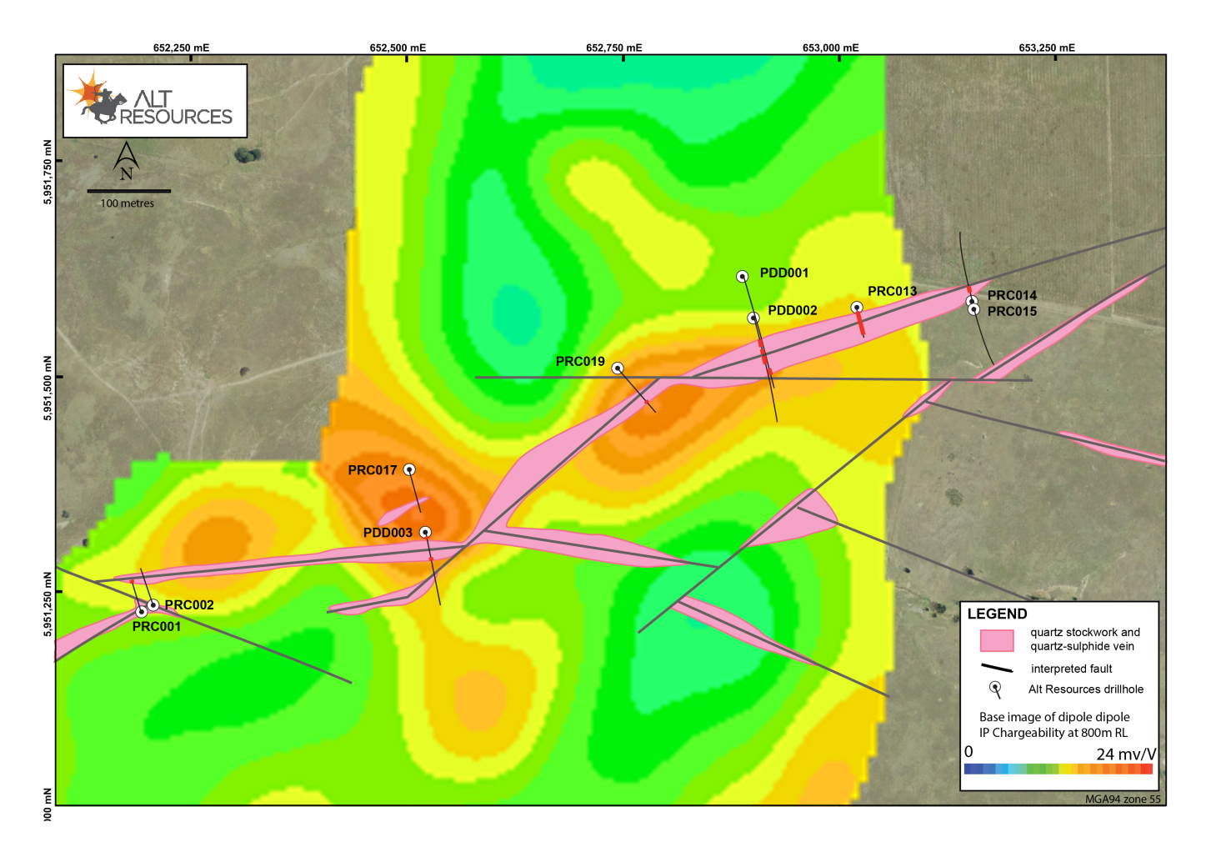 Figure 5 Tom’s Vein, showing Surface vein traces on IP chargeability response for 100m depth
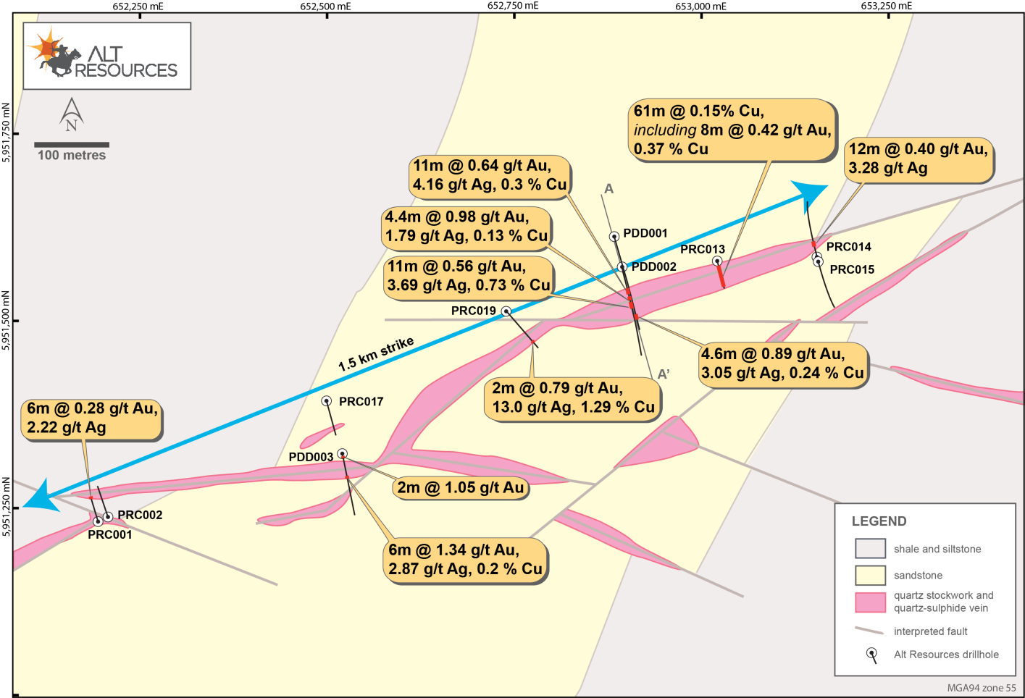
Figure 6 Tom’s Vein drilling
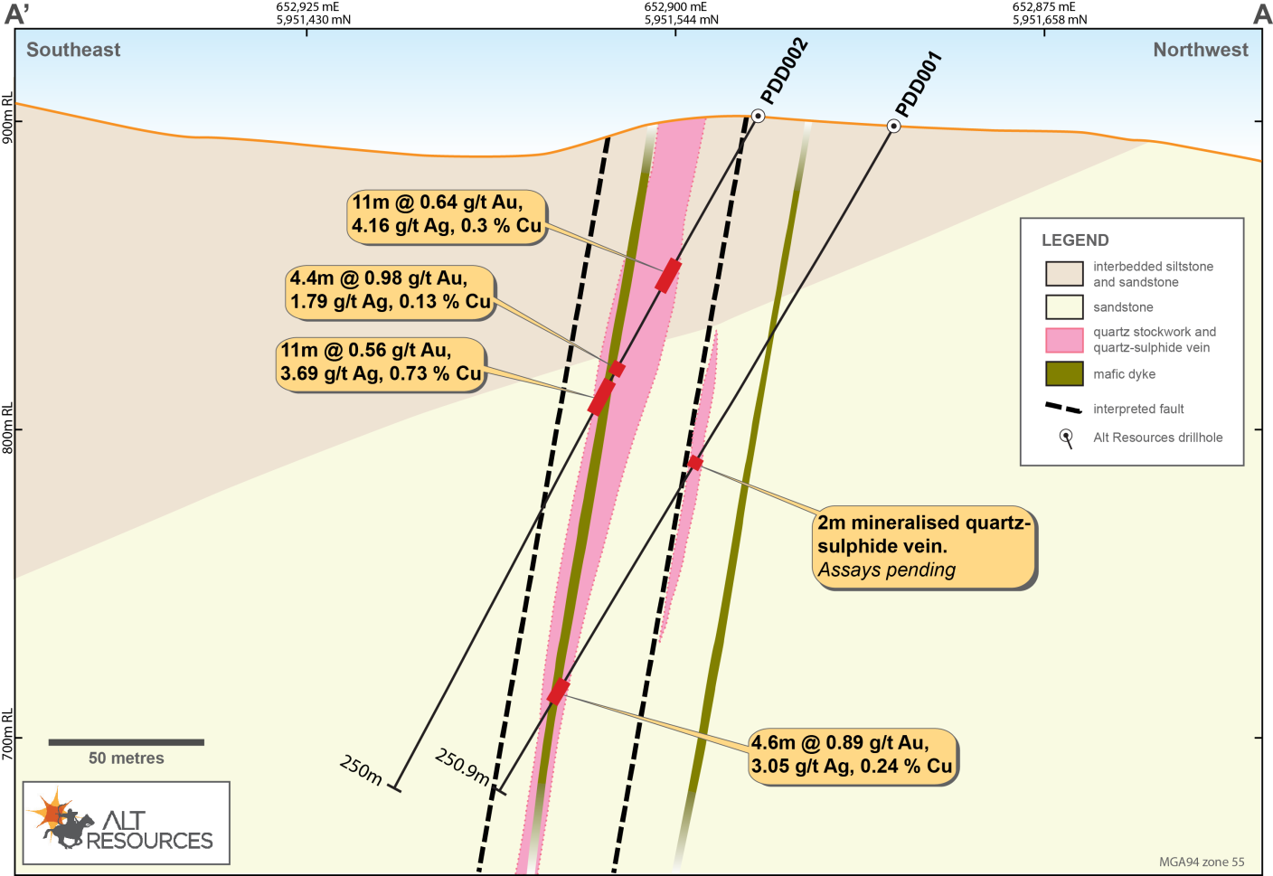
Figure 7 Tom's Vein Drill Section

Telford’s Prospect
The Telford’s prospect is a zone of broad IP response within poorly outcropping sandstone. Scattered quartz vein stockworked sandstone float shows moderately anomalous surface vein geochemistry adjacent to the Litchfield fault and south of Tom’s Vein. With the IP response increasing at depth, and stockwork quartz veining at surface, Telford’s prospect is regarded as a deeper bulk low grade gold-base metals target.
Five RC holes (PRC004 to PRC007 and PRC018) were drilled at Telford’s, but four did not reach target depth due to ground water. Therefore, the IP anomaly at Telford’s remains largely untested as shown in Figure 8. Results to date suggest that the widespread quartz vein stockwork float observed at surface is more restricted at depth. Sampling of the RC collars above the Telford’s anomaly did not return significant economic mineralisation however the base of hole PRC006 contains 47% pyrite, based on S content, with 2.8 g/t Ag, 1,250 ppm Co and 159 ppm Bi. This suggests proximity to more significant mineralisation.
All RC holes were scanned using a TerraSpec Halo NIR mineral spectrometer to ascertain alteration mineralogy as a vectoring tool for exploration targeting. At Telford’s this work showed a well-defined large scale mineralogical zonation, partly demonstrated in Figure 9 below. The mineralogical zonation progresses from pervasive clay-chlorite alteration of the host impure sandstone matrix close to surface, passing downwards into chlorite-sericite then higher grade biotite-sericite assemblages at depth, indicating proximity to an intrusive heat source.
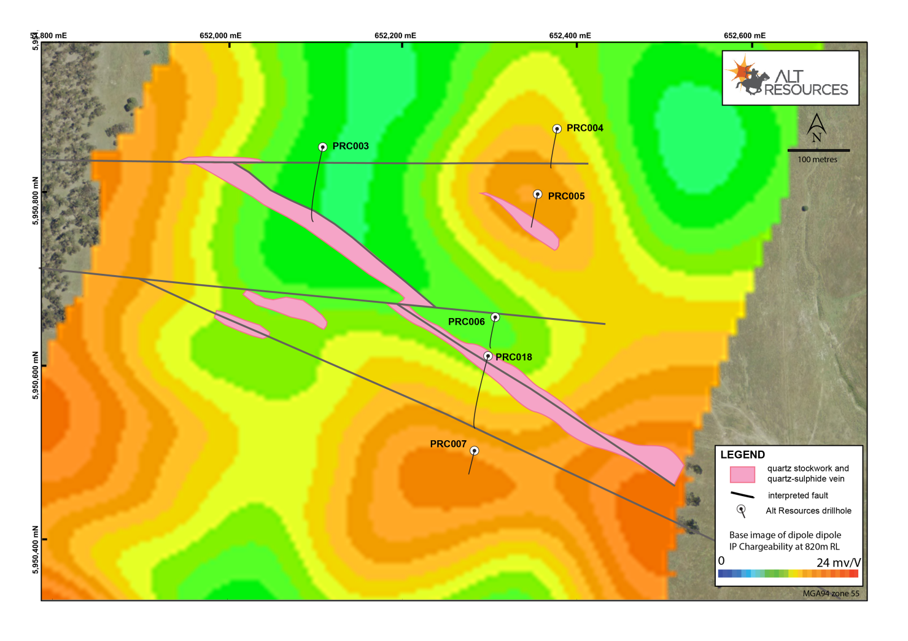
Figure 8 Telford’s Prospect, showing IP response at 80m below surface and drill locations
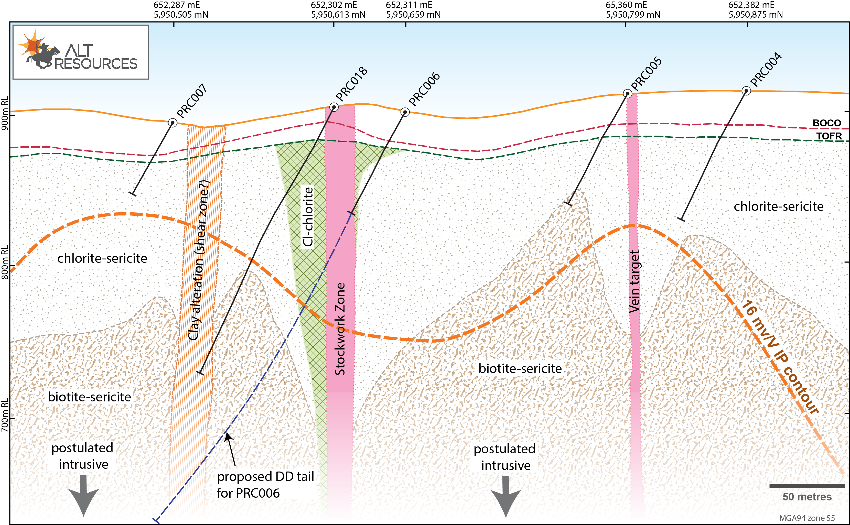
Figure 9 Telford’s drill section showing alteration interpreted from TerraSpec logging
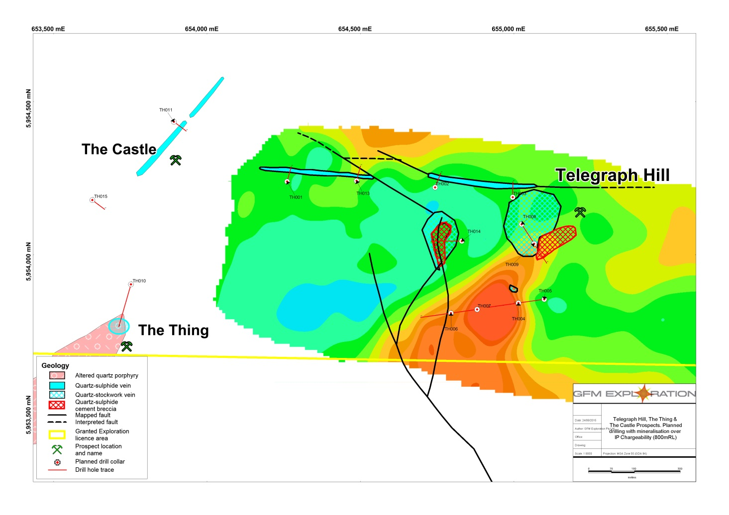
Figure 10 Telegraph Hill, showing surface interpretation and IP chargeability for 100m depth

Planned Exploration
Following on from successes with initial First Pass drilling at the Tom’s and Telford’s prospects, and consequent improved understanding of the structural controls of mineralisation, the JV plans to continue an aggressive exploration program targeting major vein and porphyry style mineralisation within the tenements (subject to raising adequate funding):
- Complete first pass drill testing of the currently defined surface gold-silver base metal vein systems at Tom’s, Telford’s, Telegraph Hill and Don’s Hill prospects, by shallow reverse circulation drilling and diamond drilling;
- Continue to expand the IP data across the tenements using both gradient array and dipole-dipole surveys to further define potential drilling targets and undertake initial drill testing of the Rock Lodge prospect at Myalla;
- Complete first pass exploration of the remainder of the Licence areas for additional gold-copper mineralised centres, using a combination of detailed aeromagnetics/radiometrics and BLEG gold geochemistry;
- Drill target definition at other currently identified prospect areas, (Quarry, Quarry South and West and the Castle using surface mapping, geochemistry and IP surveys, with follow up first pass drilling as justified by initial work; and
- Define deeper drilling targets for non-outcropping porphyry-related copper-gold mineralisation based on synthesis of the above work.

